6.10: a) From Eq. (6.6),
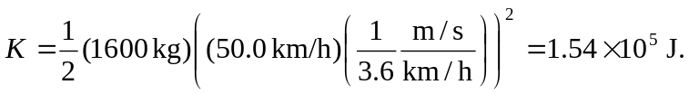
b) Equation (6.5) gives the explicit dependence of kinetic energy on speed; doubling the speed of any object increases the kinetic energy by a factor of four.

